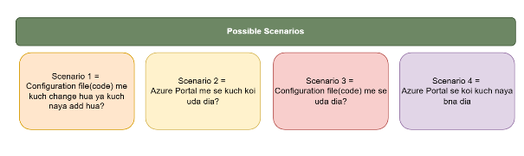

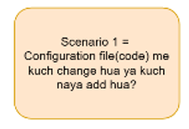
Ek RG create kara and terraform apply kara, ek RG create ho gaya Azure portal pr.
Fir humne configuration file pr kuch changes kara fir terraform apply run kara toh usne
1 add and 1 destroy show kara,
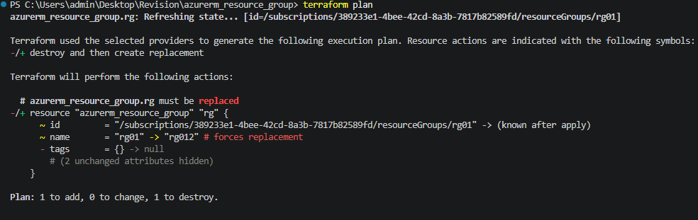

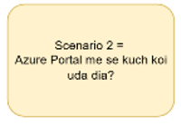
Azure portal pr humne RG remove kardiya manually and terraform se jab humne terraform plan kara toh New RG create ke liye bataya, terraform state file se match kara Azure portal se aur dekha ki portal pr resource removed hai lakin state file pr resource ki entry hai bani hue hai, terraform plan pr new create hoga.

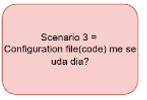

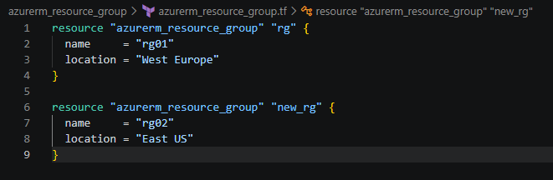

Maine new_rg block remove kar diya and terraform plan pr 1 destroy dikha raha hai, iska matlab ki ye terraform state file se match kar rha hai.
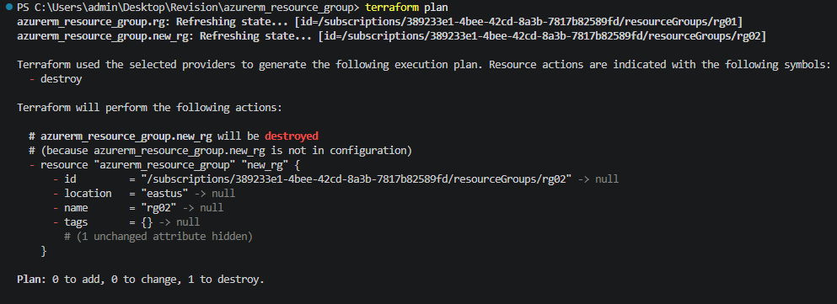

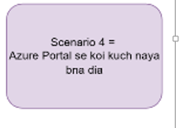
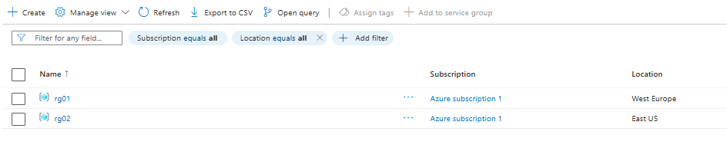
Phele 2 RGS the, abhi ek new RG manually create kar diya portal par
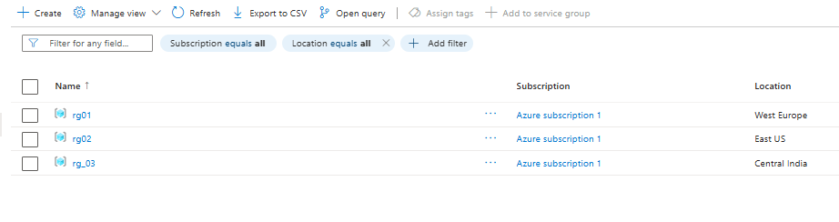
But when we ran terraform plan, it gave us the below result –
Code is truth, code hi satya hai
